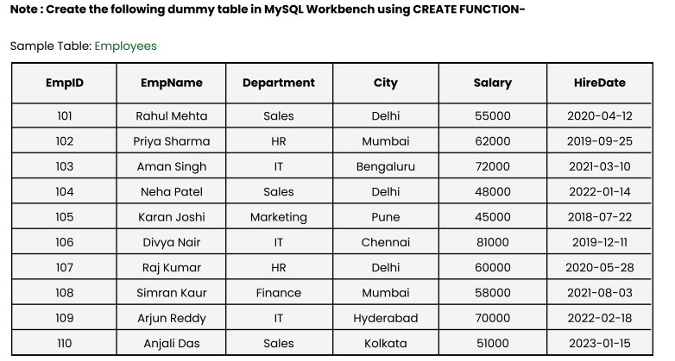

CREATE DATABASE company_filtering_db;
USE company_filtering_db;

CREATE TABLE Employees (
EmpID INT PRIMARY KEY,
EmpName VARCHAR(50),
Department VARCHAR(50),
City VARCHAR(50),
Salary INT,
HireDate DATE);

INSERT INTO Employees
VALUES
(101, 'Rahul Mehta', 'Sales', 'Delhi', 55000, '2020-04-12'),
(102, 'Priya Sharma', 'HR', 'Mumbai', 62000, '2019-09-25'),
(103, 'Aman Singh', 'IT', 'Bengaluru', 72000, '2021-03-10'),
(104, 'Neha Patel', 'Sales', 'Delhi', 48000, '2022-01-14'),
(105, 'Karan Joshi', 'Marketing', 'Pune', 45000, '2018-07-22'),
(106, 'Divya Nair', 'IT', 'Chennai', 81000, '2019-12-11'),
(107, 'Raj Kumar', 'HR', 'Delhi', 60000, '2020-05-28'),
(108, 'Simran Kaur', 'Finance', 'Mumbai', 58000, '2021-08-03'),
(109, 'Arjun Reddy', 'IT', 'Hyderabad', 70000, '2022-02-18'),
(110, 'Anjali Das', 'Sales', 'Kolkata', 51000, '2023-01-15');

Question 1: Show employees working in either the ‘IT’ or ‘HR’ departments.

Using the IN operator to filter for multiple specific values.

SELECT * FROM Employees
WHERE Department IN ('IT', 'HR');

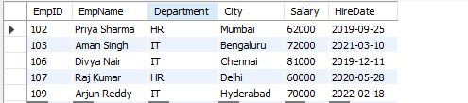
Question 2 : Retrieve employees whose department is in ‘Sales’, ‘IT’, or ‘Finance’.

Similar to Q1, we will add the third department to the list.
SELECT * FROM Employees
WHERE Department IN ('Sales', 'IT', 'Finance');
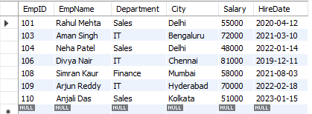

Question 3 : Display employees whose salary is between ₹50,000 and ₹70,000.

We will use the BETWEEN operator for inclusive range filtering.

SELECT * FROM Employees
WHERE Salary BETWEEN 50000 AND 70000;

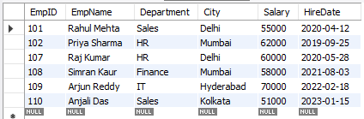
Question 4 : List employees whose names start with the letter ‘A’.

We will use the LIKE operator with the wildcard % at the end

SELECT * FROM Employees
WHERE EmpName LIKE 'A%';

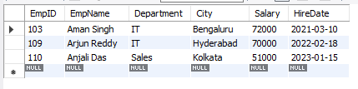
Question 5 : Find employees whose names contain the substring ‘an’.

We will place the wildcard % on both sides to find 'an' anywhere in the name (e.g., Aman, Karan).

SELECT * FROM Employees
WHERE EmpName LIKE '%an%';

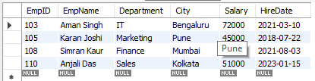

Question 6 : Show employees who are from ‘Delhi’ or ‘Mumbai’ and earn more than ₹55,000.

We will use parentheses to group the city logic separately from the salary logic to ensure the AND condition applies correctly.

SELECT * FROM Employees
WHERE City IN ('Delhi', 'Mumbai') AND Salary > 55000;

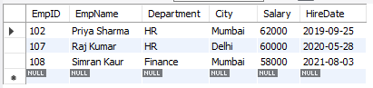
Question 7 : Display all employees except those from the ‘HR’ department.

We will use the != or <> operator to exclude specific values.

SELECT * FROM Employees
WHERE Department != 'HR';

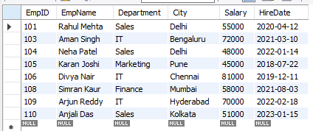
Question 8 : Get all employees hired between 2019 and 2022, ordered by HireDate (oldest first).

Filter by the year and then use ORDER BY with ASC (Ascending) to show oldest dates first.

SELECT * FROM Employees
WHERE YEAR(HireDate) BETWEEN 2019 AND 2022
ORDER BY HireDate ASC;

